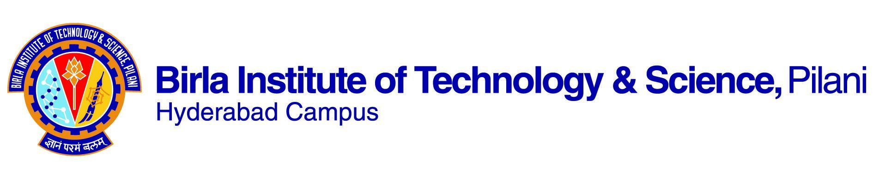

**FIRST SEMESTER 2023-2024**

# Course Handout Part II

11/08/2023

In addition to part-I (General Handout for all courses appended to the timetable), this portion gives further specific details regarding the course.

*Course No.* : **CHE F311**

## Course Title : **Kinetics and Reactor Design**

## Instructor-in-Charge : **Dr. Balaji Krishnamurthy**

**Scope and Objective of the Course:**

This course is an introduction to the chemical reaction kinetics, design, and performance of various types of chemical reactors for chemically reacting systems that yield industrially important products. The emphasis in this course will be to understand the fundamentals of the kinetics of homogeneous reactions, design and analysis of ideal reactors; and non-ideal flow.

Learning outcomes:

After studying this course, students will be able to

* Have the knowledge on what kind of reactor is suitable/best choice for what situation.
* Students will be able to analyze the kinetic related data to find the size of a reactor for a specific reaction

**Textbooks:**

1. Scott Fogler, H. Scott “Elements of Chemical Reaction Engineering”, Pearson Edu, 4th Ed, 2006.
2. Octave Levenspiel, Chemical Reaction Engineering. 3rd Ed

**Reference books**

1. Fromment G.F. and Bischoff K.B., Chemical Reactor Analysis and Design, John Wiley 1994.
2. Schmidt Lanny D., “The Engineering of Chemical Reactions”, Oxford University Press, 2nd Ed., 2005.

**Course Plan:**

|  |  |  |  |
| --- | --- | --- | --- |
| **Lecture No.** | **Learning objectives** | **Topics to be covered** | **Chapter in the Text Book** |
| L1-L3 | Introduction | Scope and objectives of the course, methodology, concept of mole balances | TB -1 Chapter-1 |
| L4-L8 | Rate Laws and Stoichiometry | Basic Definitions, Stoichiometry, Batch Systems, Flow Systems | TB -1 Chapter-3 |
| L9-L12 | Conversion and Reactor Sizing | Different types of reactors, Reactors in Series, Spacetime & Space Velocity | TB -1 Chapter-2  TB -2 Chapter-1 |
|  |  |  |  |
| L13-L16 | Isothermal Reactor Design | Design of Isothermal Reactors, e.g., Design of CSTR and PFR, recycle reactor, Pressure Drop in Reactors | TB -1 Chaper-4 |
| L17-L22 | Collection Analysis of Data  Regression | Batch reactor Data: Differential, Integral Methods, autocatalytic reaction, enzyme catalysis | TB -1 Chaper-5  TB -1 Chaper-7 |
| L23-L28 | Multiple reactions | Complex reactions, Concepts of yield, selectivity, Maximizing products in parallel, and series reactions, | TB -1 Chapter-6 |
| L29-32 | Heterogeneous reaction | Steps involve heterogeneous reactions, derivation of kinetic rate, | TB -1 Chapter-8 & 9 |
| L33-L37 | Solid catalyzed reactions | Gas-solid catalytic reaction, Pore diffusion factors, Catalyst deactivation | TB -1 Chapter-10 11 & 12 |
| L38-L42 | Basics of non-ideal reactor | Concept of RTD, and Non-ideal reactor | TB -1 Chapter-13 |

**Evaluation Scheme:**

|  |  |  |  |  |
| --- | --- | --- | --- | --- |
| **Component** | **Duration** | **Weightage (%)** | **Date & Time** | **Nature of Component** |
| Mid sem test | 1.5 hr. | 30 % | 10/10 - 2.00 - 3.30PM | 20 CB/80 OB |
| Quizzes  (min. 4) |  | 30 % | to be announced in the class | 100 OB |
| Comprehensive test | 3 hr. | 40 % | 11/12 FN | 30 CB/70 OB |

**Closed Book Test:** No reference material of any kind will be permitted inside the exam hall.

**Open Book Exam:** Use of any printed/written reference material (books and notebooks) will be permitted inside the exam hall. Computers/mobile of any kind will not be allowed inside the exam hall.

**Chamber Consultation Hour:** To be announced in the class.

**Notices:** All notices concerning this course will be displayed on the Notice Board of Chemical Engineering or CMS

**Make-up Policy:** Make-up for the mid-test and comprehensive may be granted only with prior permission and valid justification from the Instructor-in-charge. No makeup for the quizzes/class tests will be granted.

* **Academic Honesty and Integrity Policy: Academic honesty and integrity are to be maintained by all the students throughout the semester and no type of academic dishonesty is acceptable.**

**INSTRUCTOR-IN-CHARGE**

**Dr. Srikanta Dinda**